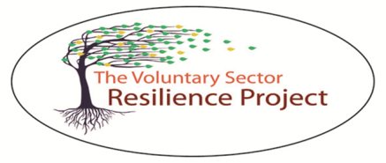
Invitation to take part in a research project: Voluntary sector adaptation and resilience in the mixed economy of criminal justice.
We are a team of researchers from Keele, Aberystwyth and South Wales Universities, working in partnership with Clinks. We are conducting research on the changes, challenges and opportunities faced by voluntary sector organisations working with offenders and their families. We are also approaching the partners of those organisations, and, policy makers, commissioners and strategic decision makers in the criminal justice field.
Our project is funded by the Leverhulme Trust, an independent research funder, and will take place over two years. We want to understand how changes in government policy, funding structures, monitoring and evaluation, partnerships and collaborations, and service user needs, affect the day to day work and operation of organisations as well as the impact this has on previously established partnerships. To this end, we are seeking to speak to individuals and organisations in the voluntary sector work in the field of offender resettlement, including aspects such as housing, drug and alcohol support, legal advice, emotional well-being and mentoring, mental health, and criminal justice interventions. We also want to engage commissioners, policy makers and strategists in the public, private and voluntary sectors working in this field, in order to probe organisational responses to change.
It is important to the research team that the sector is involved with this project from the start, and is able to provide input in terms of setting the research agenda. We want to ask the important questions and generate answers that are useful to those who take part.
During the project, we hope to engage 400 respondents through a mix of research methods; survey, interviews, focus groups and case studies. The identity of all respondents, together with their organisations will be anonymous. Any personal data provided will be kept confidential. Focus group and interviews will, with your permission, be recorded and transcribed. The survey will be hosted on-line through our partners at Clinks, and case study data will be collected through site visits and access to organisational documents where there is specific permission to do so. We can send interview and focus group questions in advance if you wish, so you have time to consider your responses, and you will also have the opportunity to review your transcripts. You can find out more information in the attached document, and if you have any further questions, please feel free to contact us.
If you are interested in talking to us about your experiences and opinions, or taking part in the survey, please contact us:
Dr. Mary Corcoran (Lead Investigator) | research.corcoran.resilience@keele.ac.uk  01782 733104
Dr. Kelly Prince (Research Associate) | k.l.prince@keele.ac.uk  01782 734865
Kate Williams (Research Partner) | khw@aber.ac.uk
Nathan Dick (Research Partner) | Nathan.Dick@clinks.org
Prof. Mike Maguire (Research Partner) | University of South Wales

Thank you for your time.

